Product Design for a Friend Matching App

Goldsmiths, university of london

Designing digital interactions

Sana Chikkam

**Contents**

1. App Context and Background………………………………………………..Page 3
2. App Purpose and Goals………..……………………………………………….Page 3
3. Stakeholders and User Groups………………………………………………Page 4
4. User Personas……………………………………………………………………….Page 5
5. User Stories…………………………………………………………………………..Page 7
6. Storyboards…………………………………………………………………………..Page 8
7. Screen Designs………………………………………………………………………Page 12
8. Prototypes…………………………………………………………………………….Page 14
9. Cognitive Walkthrough Evaluation…………………………………………Page 18
10. Findings and Reflection………………………………………………………….Page 26
11. App Context and Background

This app is designed as a simple way for a person to make small groups of friends. It is convenient because the app will match them with people who they are compatible with. This can help save time and reduce any potential heartache or stress when people are struggling to find the right friends.  
  
This app would be needed because loneliness is an ever-growing issue that many people face, and this app would help combat that. Even for people who are not experiencing loneliness, this app would still be useful to them since it would give them a convenient opportunity to meet new friends. This app would also help give people who are shy the push they need to take the initiative and put themselves out there since it gives them a simple way to do so.  
  
The app would be useful for all those people because it can be difficult to meet people who share similar interests and schedules to you, especially when they lead busy lives. This app would make it far less draining to meet people who click with you and have the potential to become some of your closest friends.  
  
A similar app exists called We3. Some things it does well is that it is quick and simple to use and matches people based on the results of a detailed personality test they complete. It does have a few issues though, such as matching users with inactive profiles (or with people who live extremely far away). It is also buggy at times, with buttons sometimes missing, the facial recognition of photos not working and the interface not always aligning with the device screen. Additionally, as there are not many active users and We3 will only let you form groups of three, matches can often be lost because the connection between the group must be made within 24 hours. Even if two of the three people respond in time and those two want to stay connected, they unfortunately will not be able to stay in touch if the third person does not respond or if they are not interested in the third person.

1. App Purpose and Goals

When the user creates an account, the app will ask the user a few questions. For example, the maximum distance of how far away they are happy to be matched with people. Another question would be how many people they would like to get matched with - the group size ranges from 3 to 6. Then after signing in, the app will ask the user a few more questions, relating to their hobbies and what they desire in a friend. Based on their answers, it will match the user with a group of people whose personalities match well and who share common interests. The app will then inform the group what they have in common and will give suggestions on activities they could do together.

1. Stakeholders and User Groups

Primary stakeholders:

* **People experiencing loneliness or anyone who wants to find new friends (1st main category) -** These people are likely to use the app the most frequently since they are the target audience.
* **People who have just moved to a new area (2nd main category) -** Whether they have moved within or outside their country, they are likely to use the app frequently as it can be difficult making friends in a new area.
* **People who are unemployed and stay at home -** They may not experience much social interaction so it may be tricky for them to put themselves out there. Therefore, using the app can help give them the push they need to talk to new people make friends.
* **Software engineers -** They will use the app regularly whilst building it.

Secondary stakeholders:

* **Representatives or volunteers from charities supporting loneliness** - They could use the app to recommend it to people experiencing loneliness and explain how it works to them if necessary.
* **Quality assurance specialists** - They would test the app as and when required to check that it is running smoothly.

1. User Personas

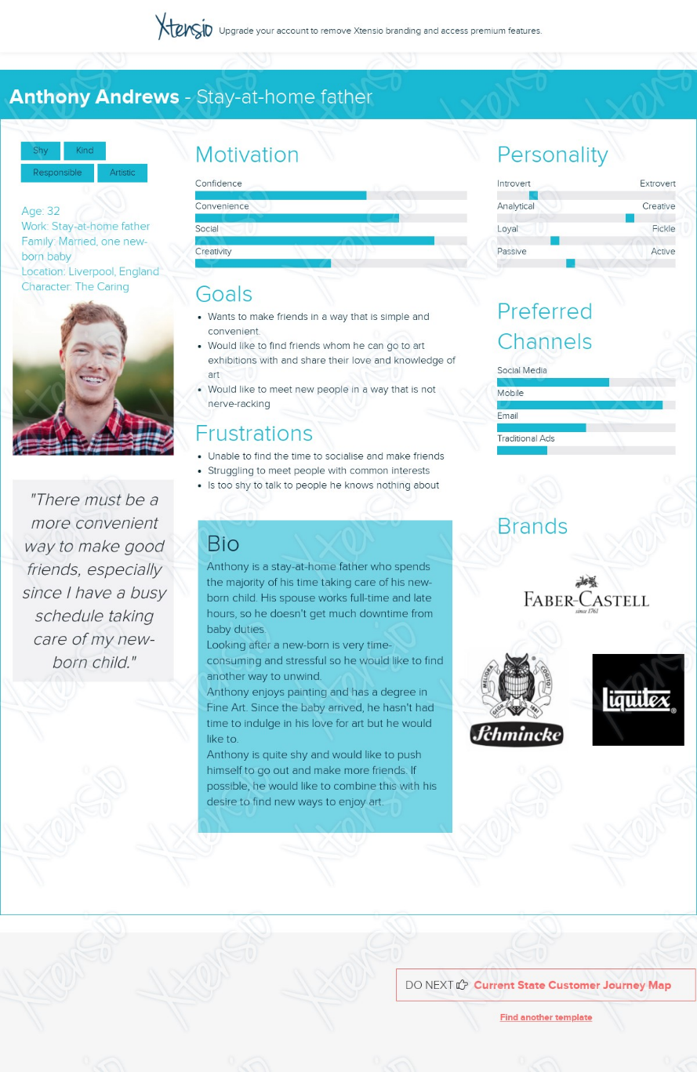

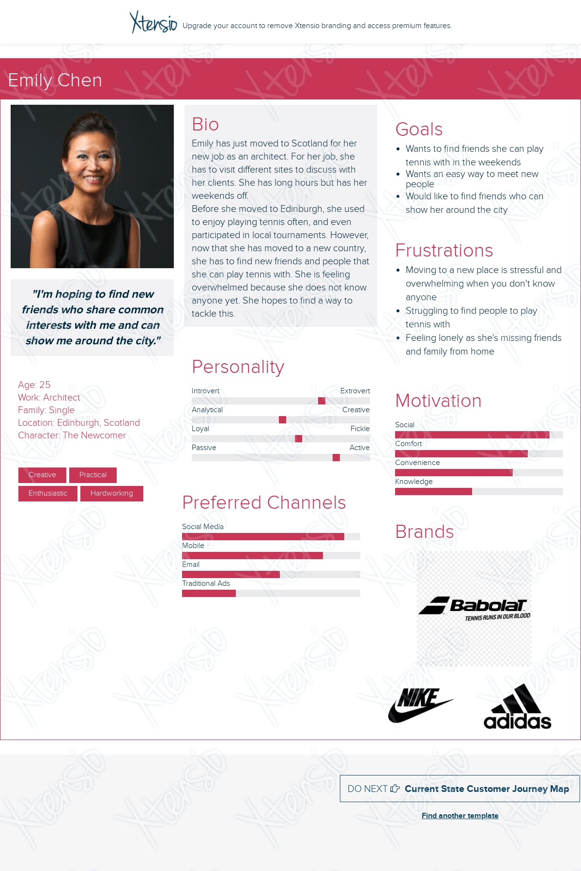

1. User Stories

Persona 1: Anthony Andrews

As a stay-at-home father who spends most of his time at home, I want a simple way to make friends so that I can socialise and interact with more people.

As a stay-at-home father who is a shy person, I want a less stressful way to talk to new people so that I will feel less anxious and more comfortable when making new friends.

Persona 2: Emily Chen

As an architect who has just moved to a new country, I want to meet locals so that they can show me around the city.

As an architect who loves tennis, I want to meet people who share common interests with me so that I can befriend people whom I can enjoy playing tennis with.

1. Storyboards

Persona 1: Anthony Andrews

As a stay-at-home father who spends most of his time at home, I want a simple way to make friends so that I can socialise and interact with more people.

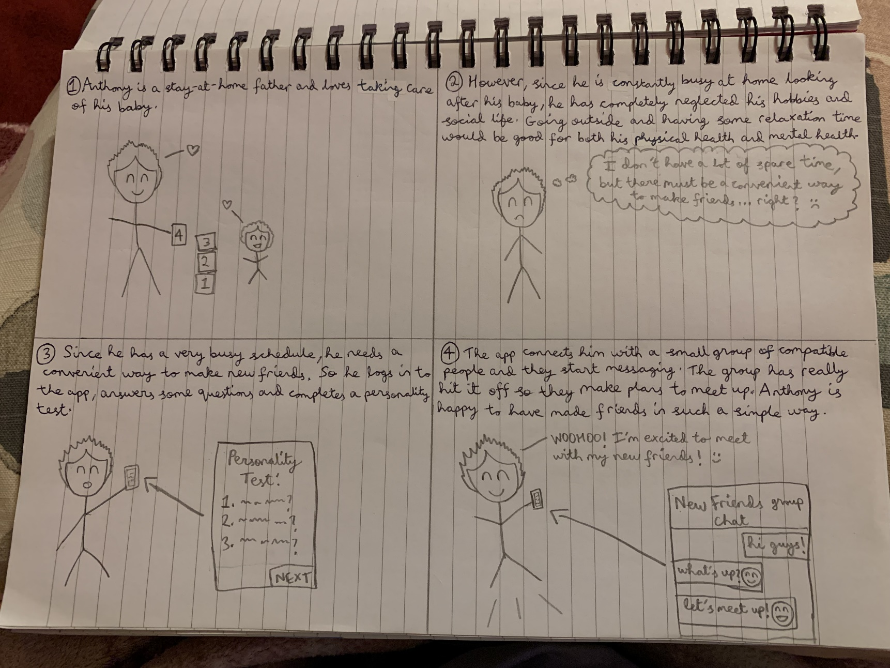

Persona 1: Anthony Andrews

As a stay-at-home father who is a shy person, I want a less stressful way to talk to new people so that I will feel less anxious and more comfortable when making new friends.

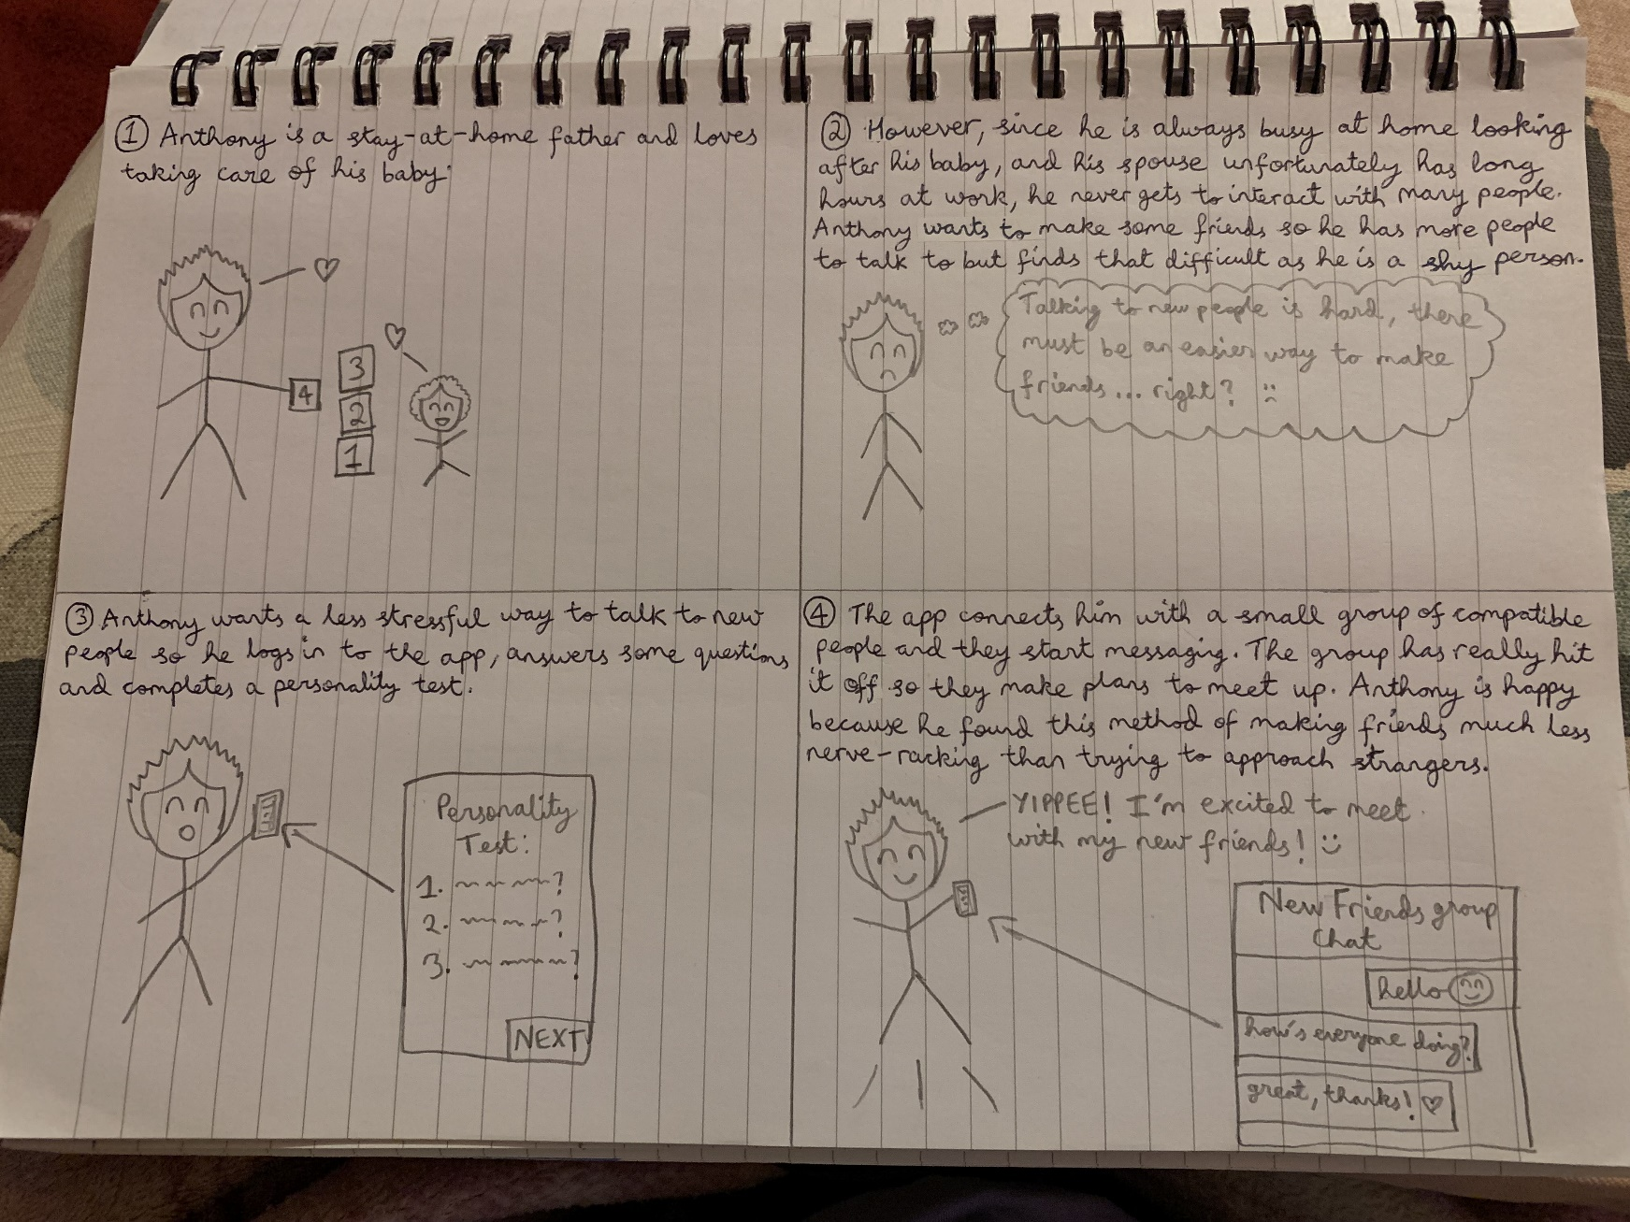

Persona 2: Emily Chen

As an architect who has just moved to a new country, I want to meet locals so that they can show me around the city.

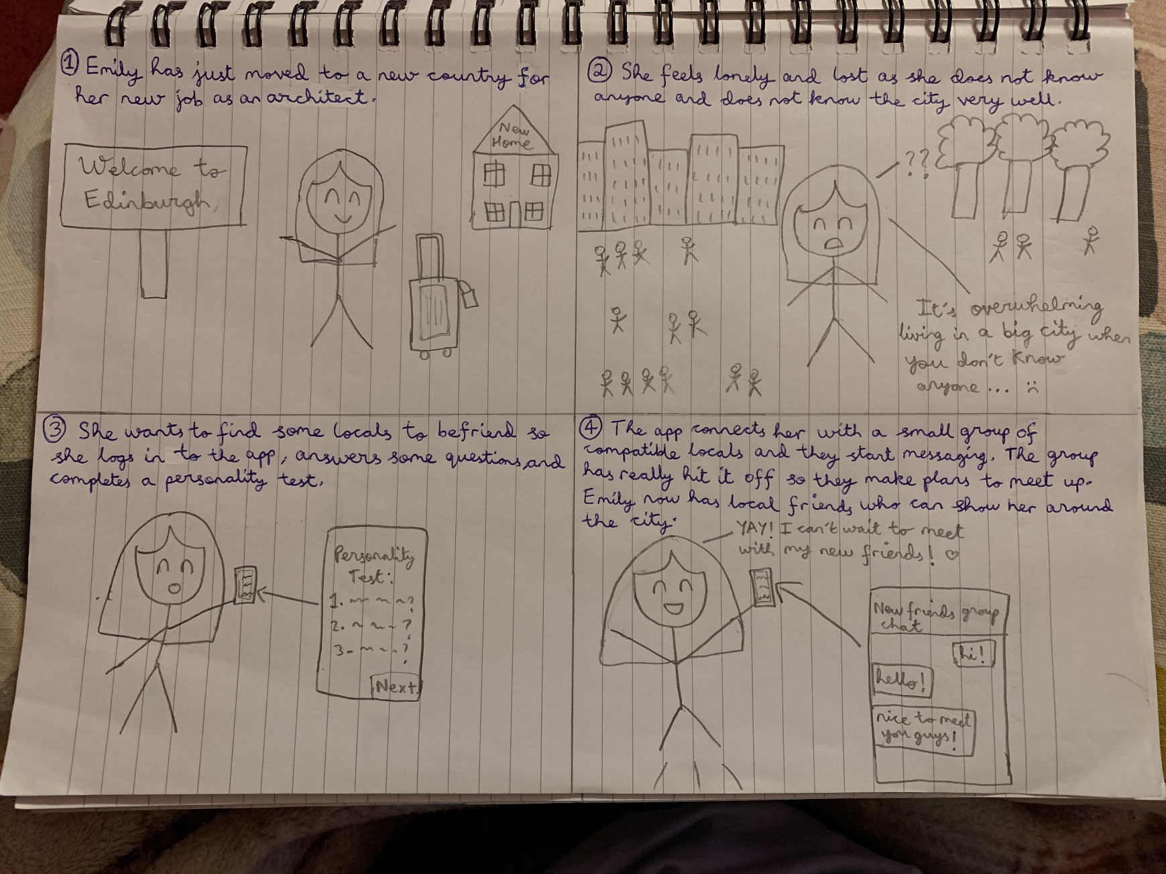

Persona 2: Emily Chen

As an architect who loves tennis, I want to meet people who share common interests with me so that I can befriend people whom I can enjoy playing tennis with.

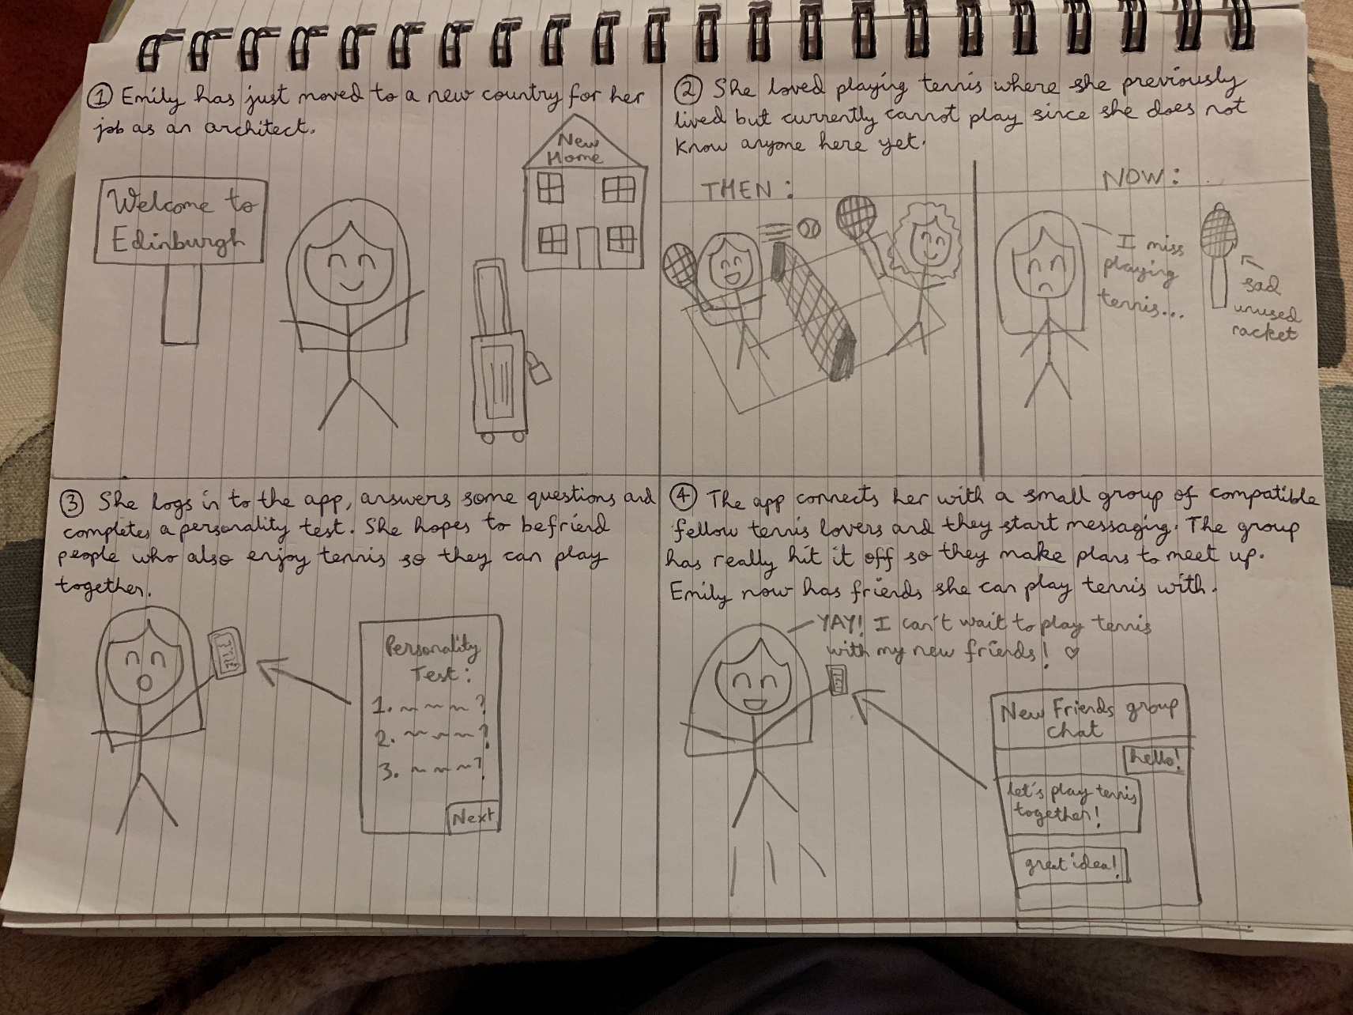

1. 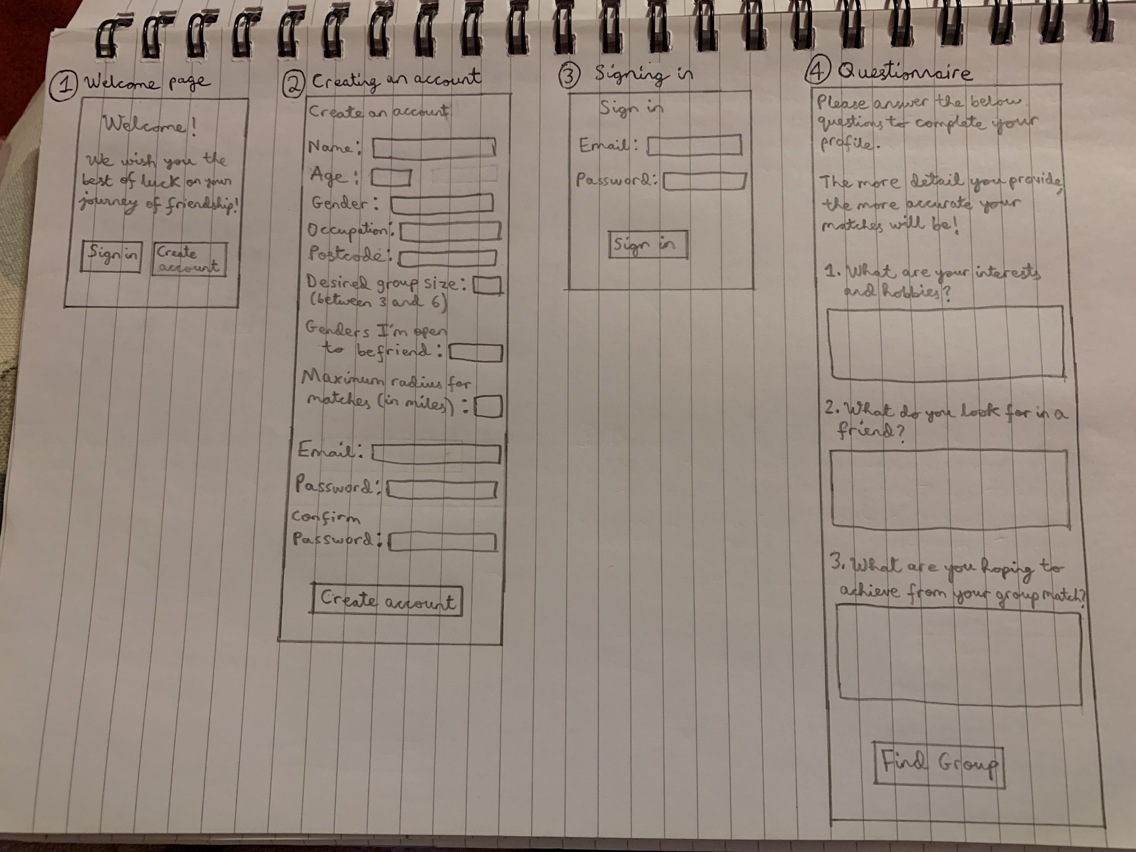Screen Designs

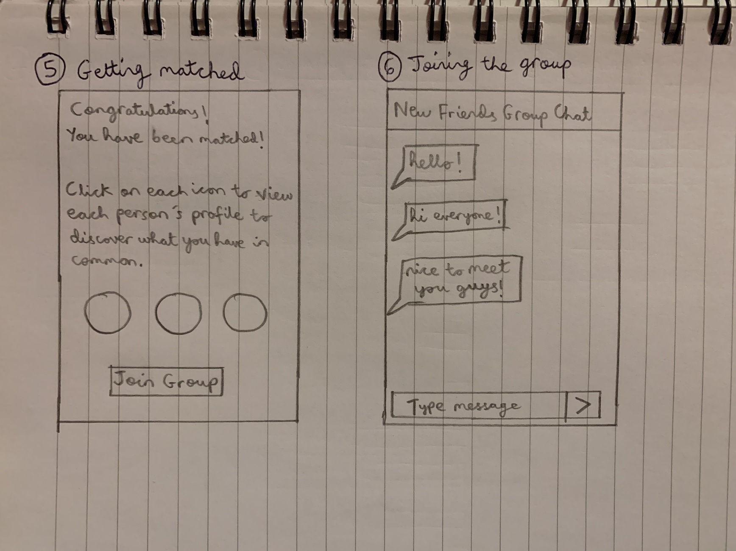  
  
  
  
  
All the backgrounds of the screens would be pastel yellow, as it is a pleasant colour, easy on the eyes, and the colour yellow represents friendship. The buttons would be pastel blue. The text would be black to make it clear to read.  
  
  
  
  
  
  
  
8) Prototypes

Persona 1: Anthony Andrews

As a stay-at-home father who spends most of his time at home, I want a simple way to make friends so that I can socialise and interact with more people.

As a stay-at-home father who is a shy person, I want a less stressful way to talk to new people so that I will feel less anxious and more comfortable when making new friends.

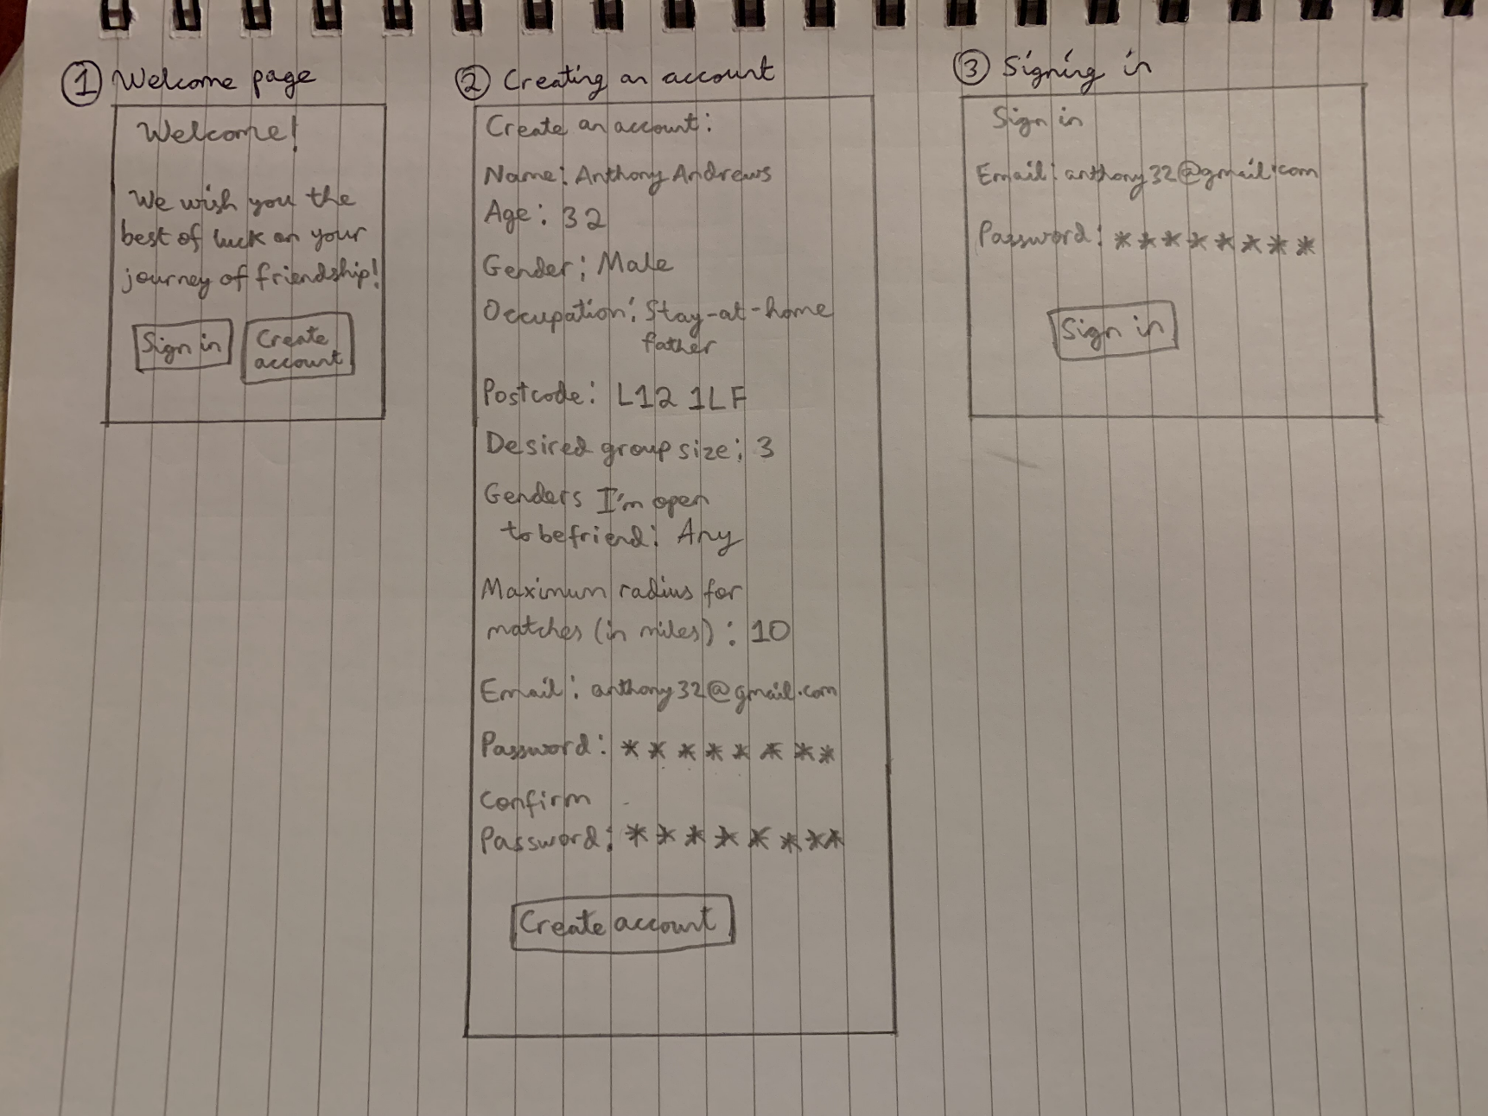

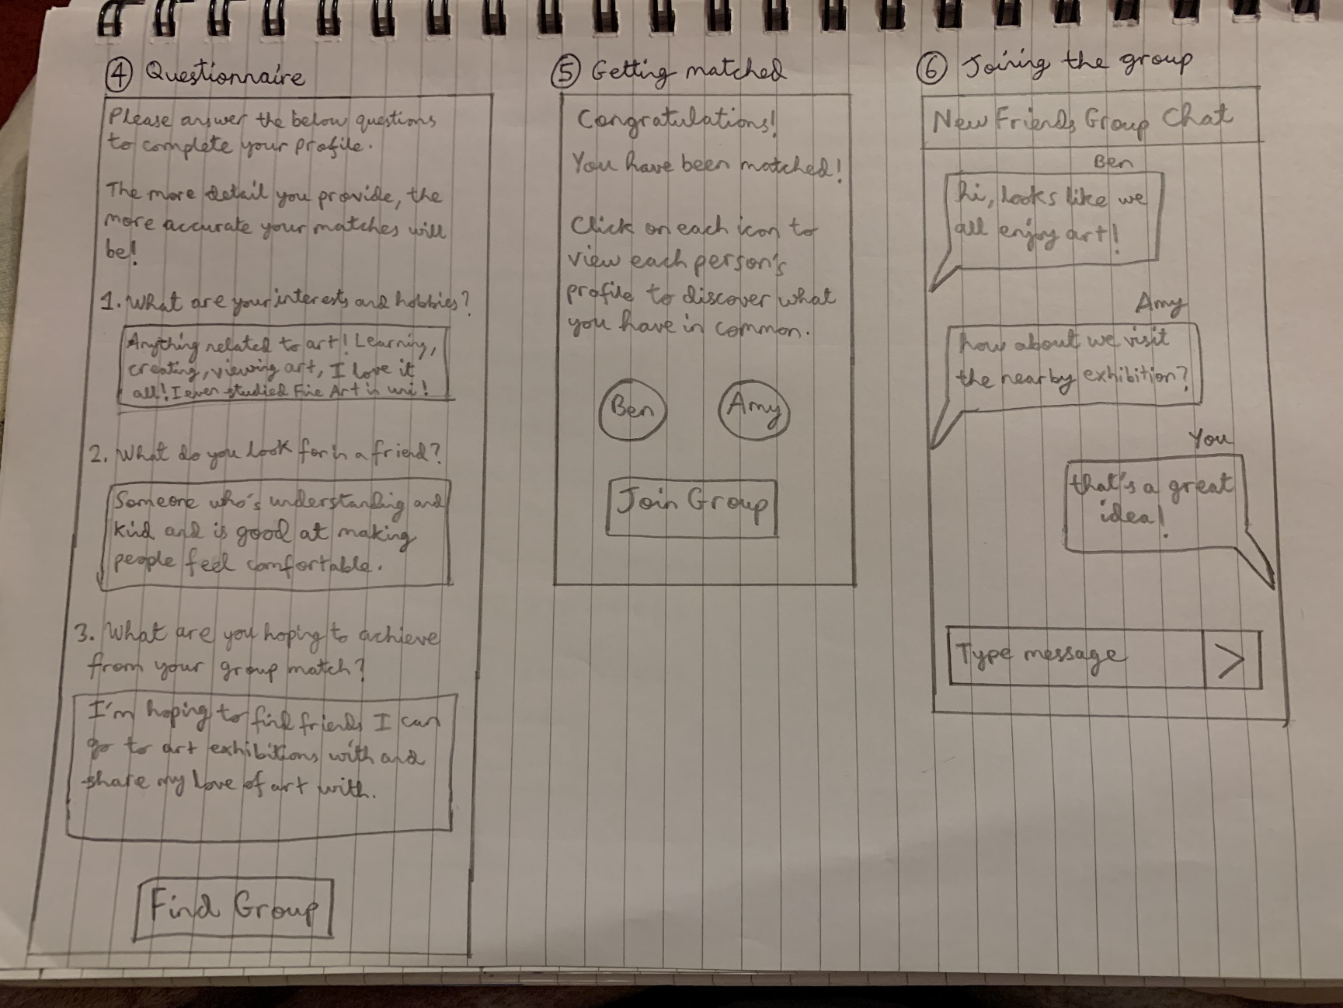

Persona 2: Emily Chen

As an architect who has just moved to a new country, I want to meet locals so that they can show me around the city.

As an architect who loves tennis, I want to meet people who share common interests with me so that I can befriend people whom I can enjoy playing tennis with.

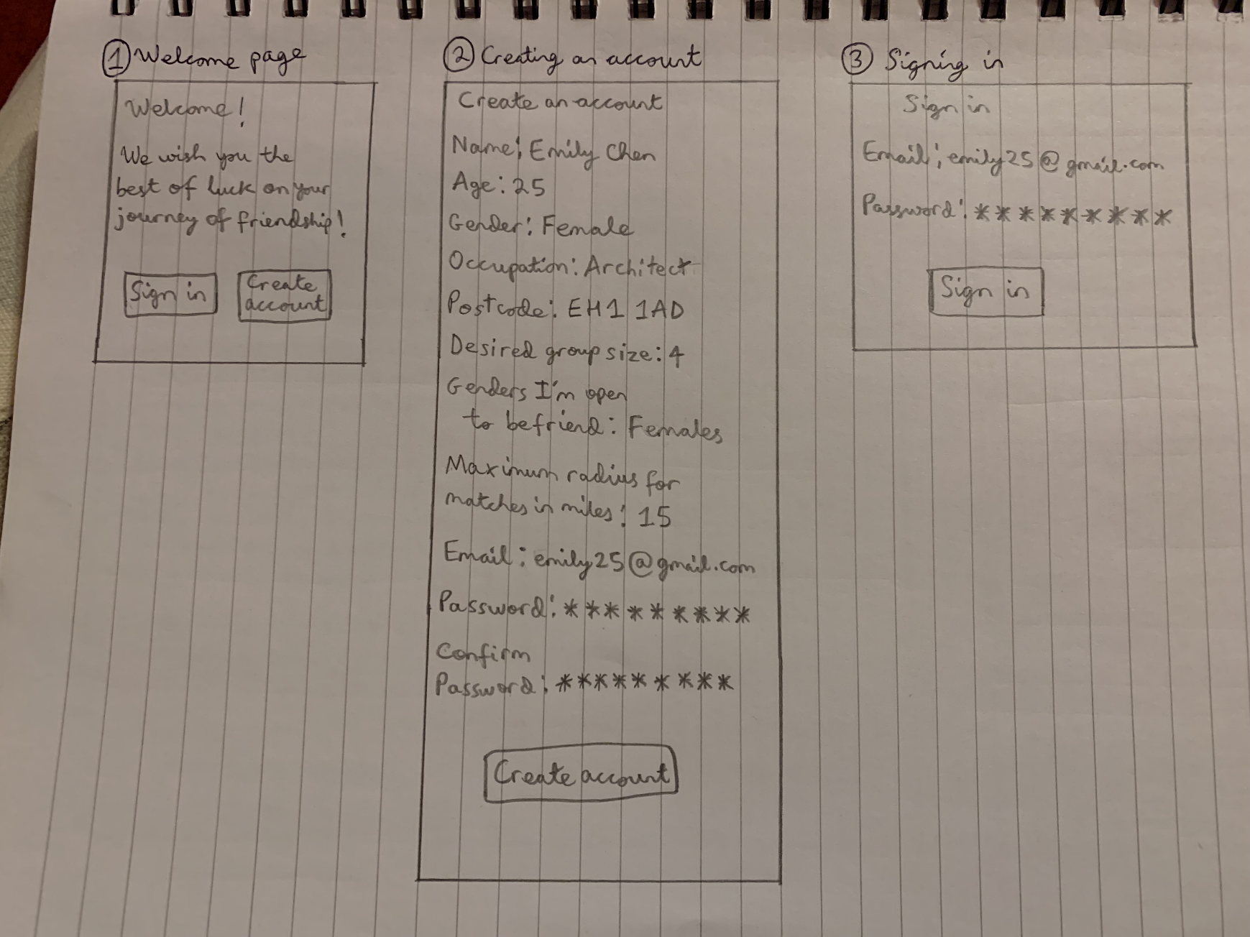

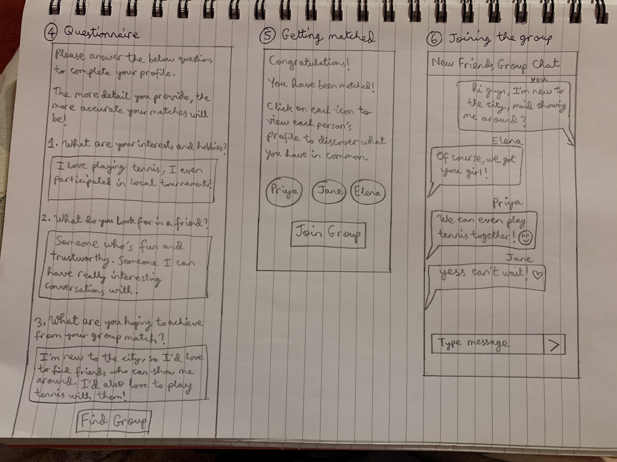

9) Cognitive Walkthrough Evaluation

A cognitive walkthrough was conducted. The following questions were asked at every stage:

a. Will the user try to achieve the right effect? (Will the user know what to do to achieve the task?)

b. Will the user notice that the correct action is available? (Is the control for the action visible?)

c. Will the user associate the correct action with the effect to be achieved? (Are there any jargon terms, or misleading labels?)

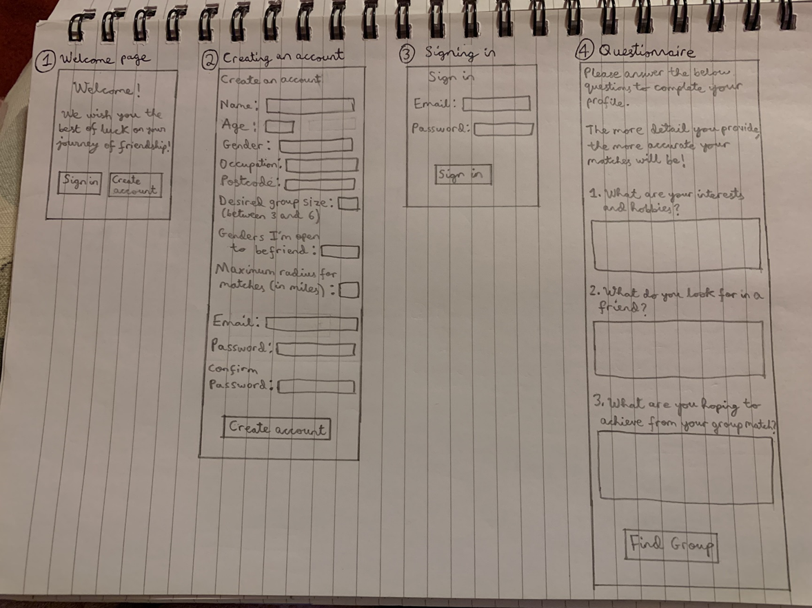d. If the correct action is performed, will the user see that progress is being made toward completing the task? (Is the feedback clear for the user?)

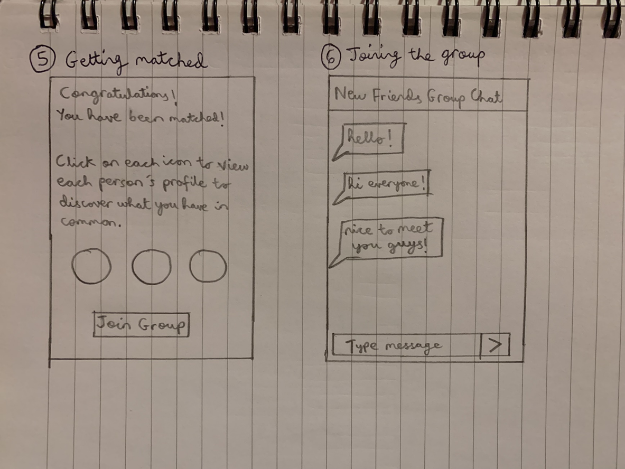

Persona 1: Anthony Andrews

As a stay-at-home father who spends most of his time at home, I want a simple way to make friends so that I can socialise and interact with more people.

As a stay-at-home father who is a shy person, I want a less stressful way to talk to new people so that I will feel less anxious and more comfortable when making new friends.

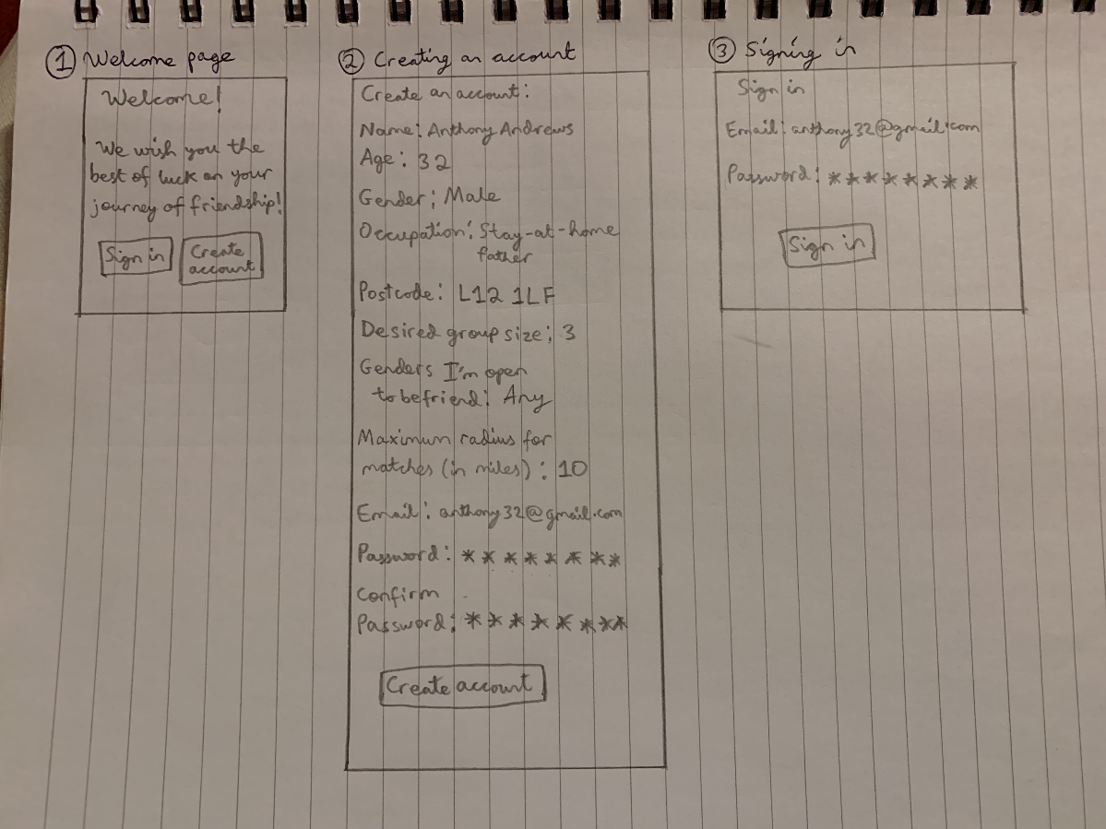

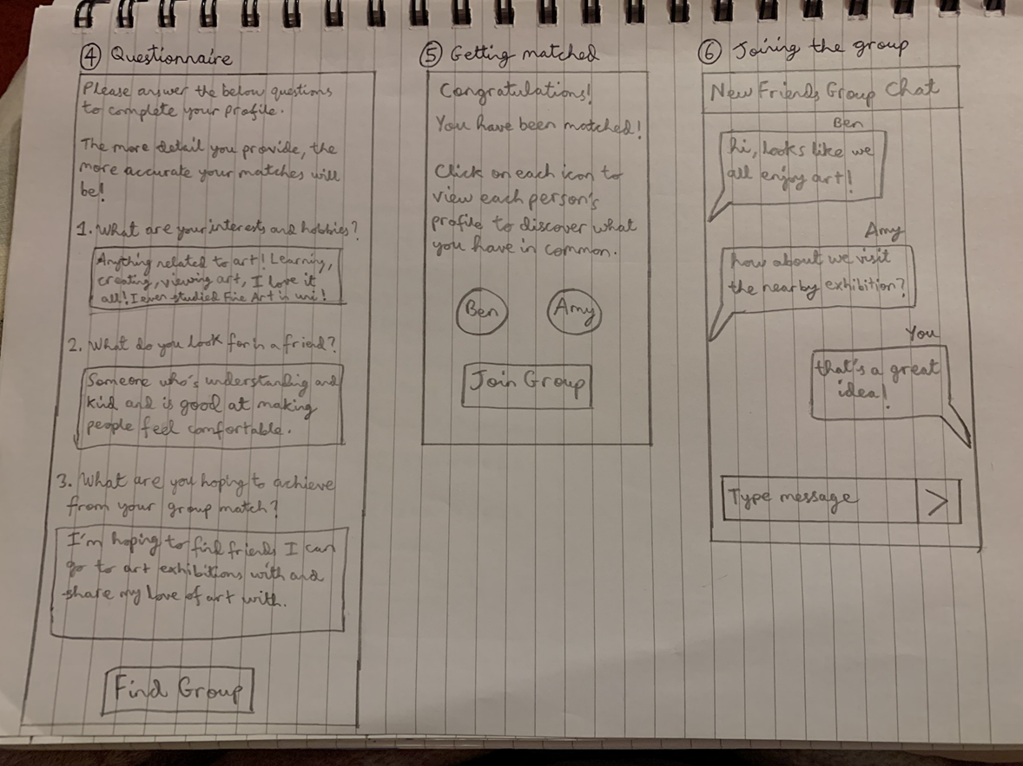

Persona 2: Emily Chen

As an architect who has just moved to a new country, I want to meet locals so that they can show me around the city.

As an architect who loves tennis, I want to meet people who share common interests with me so that I can befriend people whom I can enjoy playing tennis with.

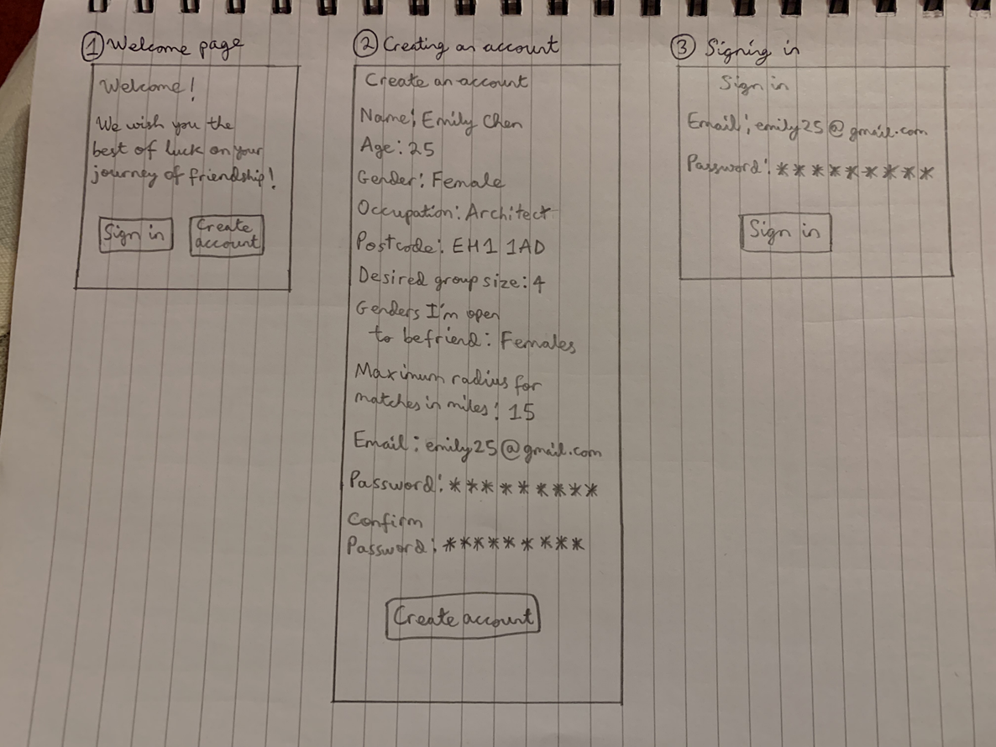  
  
  
  
  
  
  
  
  
  
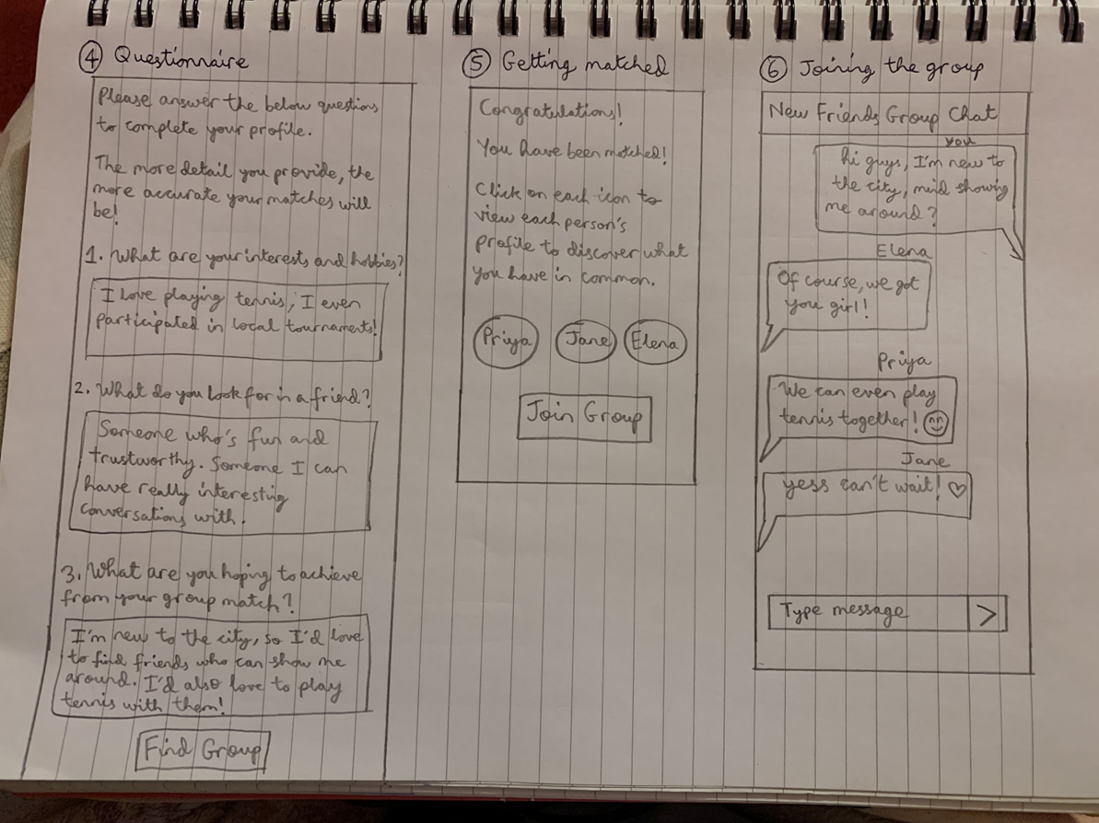  
  
**Cognitive walkthrough:**

1. Welcome Page:
2. Yes - The users will know that they must press the ‘Sign in’ button to sign in and the ‘Create account’ button to create an account.
3. Yes - The buttons to perform these actions are clearly visible.
4. Yes - The users will associate the ‘Sign in’ button for signing in and the ‘Create account’ button for creating an account as the terms used are the same so no confusion will be caused.
5. Yes - The feedback is clear for the users since they will be taken to a ‘Sign in’ page when they press the ‘Sign in’ button. Similarly, they will be taken to a ‘Create an account’ page when they press the ‘Create account’ button.
6. Creating an account:
7. Yes - The users will know that they must type their answers next to the prompts and that they should press the ‘create account’ button to proceed.
8. Yes - Before typing, the text boxes to type are present next to the prompts. The button to create the account is also clearly visible.
9. Yes - The users will associate the ‘Create account’ button for creating an account as the terms used are the same so no confusion will be caused.
10. No - The feedback may not be clear for the users since they will directly be taken to a ‘Sign in’ page when they press the ‘Create account’ button. To fix this, I should add a page in between which confirms that the user has successfully created their account before proceeding to the sign in page.

1. Signing in:
2. Yes - The users will know that they must type their answers next to the prompts and that they should press the ‘Sign in’ button to proceed.
3. Yes - Before typing, the text boxes to type are present next to the prompts. The button to sign in is also clearly visible.
4. Yes - The users will associate the ‘Sign in’ button for signing in as the terms used are the same so no confusion will be caused.
5. No - The feedback may not be clear for the users since they will directly be taken to a questionnaire page when they press the ‘Sign in’ button. To fix this, I could add a page in between which confirms that the user has successfully signed in before proceeding to the questionnaire page.

4. Questionnaire:

1. Yes - The users will know that they must type their answers in the text boxes and that they should press the ‘Find group’ button to proceed.
2. Yes - The text boxes to type are present under the questions. The button to find the group is also clearly visible.
3. Yes - The users will associate the ‘Find group’ button for finding a group as the terms used are the same so no confusion will be caused.
4. Yes - The feedback is clear for the users since they will directly be taken to a page which confirms that they have been matched with a group.
5. Getting matched:
6. Yes - The users are told to click the icons to view profiles. The users will know that they should press the ‘Join group’ button to proceed.
7. Yes - The buttons to click the profile icons and to join a group are clearly visible.
8. Yes - The users will associate the ‘Join group’ button for joining the group as the terms used are the same so no confusion will be caused.
9. Yes - The feedback is clear for the users since they will directly be taken to a group chat after clicking ‘Join group’.
10. Joining the group:
11. Yes - The users will know that they should press the ‘type message’ bar to type their message and click the right button to send their message.
12. Yes - The text bar and send button are clearly visible.
13. Yes - The users will associate the text bar with typing a message and the right button to send the message because they resemble buttons used to type and send messages for most apps and websites so no confusion will be caused.
14. Yes - The feedback is clear for the users since their message will immediately be sent when they click the right button.

10) Findings and Reflection

When performing cognitive walkthrough, I noticed that the users may not be certain if they have successfully created an account since after pressing the ‘create account’ button, they would directly be taken to a ‘sign in’ page. To address this, I could add a page in between which confirms that the user has successfully created their account before proceeding to the sign in page.

Also, I noticed that the users may not be certain if they have successfully signed in since after pressing the ‘sign in’ button, they would directly be taken to a questionnaire page. To address this, I could add a page in between which confirms that the user has successfully signed in before proceeding to the questionnaire page.

Also, when trying to create an account or sign in or complete the questionnaire, it may not be clear to the users that they must answer every prompt and question to continue to the next page. To address this, I could include a message on each of these pages stating that every prompt must be answered to be able to move on to the next page.

Additionally, when the user has to input their desired group size when creating an account, it is not clear if the number they input includes themselves or not (which it does). To address this, I could specify under that prompt that the number the user inputs includes themselves as one of the people in the group.

Another improvement I could add is a home page and navigation menu.

This process highlighted to me the importance of reflecting on my work even after it is finished, as there is still opportunity to improve and add more value. In this case, performing a cognitive walkthrough allowed me to think of ideas to refine the app and make it more user-friendly.